Name : Sahil Saini
Reg No: 180905048
Roll No : 11C

Question1:
Create a web form which allows the teacher to enter the student details like name,
date of birth, address, contact number, email id and marks of English, Physics and
Chemistry. After filling all the information and on clicking submit button, details
should be added to a textarea displayed on the same page. Display the total
percentage of marks obtained in a label.

Project App Files

asgi.py

import os

from django.core.asgi import get_asgi_application

os.environ.setdefault('DJANGO_SETTINGS_MODULE', 'Question1.settings')

application = get_asgi_application()

settings.py

"""
Django settings for Question1 project.

Generated by 'django-admin startproject' using Django 3.2.

For more information on this file, see
https://docs.djangoproject.com/en/3.2/topics/settings/

For the full list of settings and their values, see
https://docs.djangoproject.com/en/3.2/ref/settings/
"""

from pathlib import Path
import os

# Build paths inside the project like this: BASE_DIR / 'subdir'.
BASE_DIR = Path(__file__).resolve().parent.parent

templates_path=os.path.join(BASE_DIR,'templates')

# Quick-start development settings - unsuitable for production
# See https://docs.djangoproject.com/en/3.2/howto/deployment/checklist/

# SECURITY WARNING: keep the secret key used in production secret!
SECRET_KEY = 'django-insecure-2dbiv@u#k#_s6o%drul3umlkfro5v!*4ps3-mzfv=)30%3v8aj'

# SECURITY WARNING: don't run with debug turned on in production!
DEBUG = True

ALLOWED_HOSTS = []

# Application definition

INSTALLED_APPS = [
'Question',
'django.contrib.admin',
'django.contrib.auth',
'django.contrib.contenttypes',
'django.contrib.sessions',
'django.contrib.messages',
'django.contrib.staticfiles',
]

MIDDLEWARE = [
'django.middleware.security.SecurityMiddleware',
'django.contrib.sessions.middleware.SessionMiddleware',
'django.middleware.common.CommonMiddleware',
'django.middleware.csrf.CsrfViewMiddleware',
'django.contrib.auth.middleware.AuthenticationMiddleware',
'django.contrib.messages.middleware.MessageMiddleware',
'django.middleware.clickjacking.XFrameOptionsMiddleware',
]

ROOT_URLCONF = 'Question1.urls'

TEMPLATES = [
{

'BACKEND': 'django.template.backends.django.DjangoTemplates',
'DIRS': [templates_path],
'APP_DIRS': True,
'OPTIONS': {
'context_processors': [
'django.template.context_processors.debug',
'django.template.context_processors.request',
'django.contrib.auth.context_processors.auth',
'django.contrib.messages.context_processors.messages',
],
},
},
]

WSGI_APPLICATION = 'Question1.wsgi.application'

# Database
# https://docs.djangoproject.com/en/3.2/ref/settings/#databases

DATABASES = {
'default': {
'ENGINE': 'django.db.backends.sqlite3',
'NAME': BASE_DIR / 'db.sqlite3',
}
}

# Password validation
# https://docs.djangoproject.com/en/3.2/ref/settings/#auth-password-validators

AUTH_PASSWORD_VALIDATORS = [
{
'NAME': 'django.contrib.auth.password_validation.UserAttributeSimilarityValidator',
},
{
'NAME': 'django.contrib.auth.password_validation.MinimumLengthValidator',
},
{
'NAME': 'django.contrib.auth.password_validation.CommonPasswordValidator',
},
{
'NAME': 'django.contrib.auth.password_validation.NumericPasswordValidator',
},
]

# Internationalization
# https://docs.djangoproject.com/en/3.2/topics/i18n/

LANGUAGE_CODE = 'en-us'

TIME_ZONE = 'UTC'

USE_I18N = True

USE_L10N = True

USE_TZ = True

# Static files (CSS, JavaScript, Images)
# https://docs.djangoproject.com/en/3.2/howto/static-files/

STATIC_URL = '/static/'

# Default primary key field type
# https://docs.djangoproject.com/en/3.2/ref/settings/#default-auto-field

DEFAULT_AUTO_FIELD = 'django.db.models.BigAutoField'

urls.py

from django.contrib import admin
from django.urls import path, include
import Question

urlpatterns = [
path('admin/', admin.site.urls),
path('', include('Question.urls')),
]

wsgi.py

import os

from django.core.wsgi import get_wsgi_application

os.environ.setdefault('DJANGO_SETTINGS_MODULE', 'Question1.settings')

application = get_wsgi_application()

User App Files

apps.py

from django.apps import AppConfig

class QuestionConfig(AppConfig):
default_auto_field = 'django.db.models.BigAutoField'
name = 'Question'

urls.py

from django.contrib import admin
from django.urls import path

from Question import views

urlpatterns = [
path('admin/', admin.site.urls),
path('', views.index),
]

views.py

from django.shortcuts import render

# Create your views here.

from django.http import HttpResponse

def index(request):
return render(request,'index.html',context=None)

Templates

index.html

<!DOCTYPE html>
<html lang="en">

<head>
<meta charset="UTF-8">
<meta http-equiv="X-UA-Compatible" content="IE=edge">
<script src="https://ajax.googleapis.com/ajax/libs/jquery/3.5.1/jquery.min.js"></script>
<meta name="viewport" content="width=device-width, initial-scale=1.0">
<link rel="stylesheet" href="https://stackpath.bootstrapcdn.com/bootstrap/4.4.1/css/bootstrap.min.css"
integrity="sha384-Vkoo8x4CGsO3+Hhxv8T/Q5PaXtkKtu6ug5TOeNV6gBiFeWPGFN9MuhOf23Q9Ifjh" crossorigin="anonymous">
<title>Index Page</title>
<script>
// function myfunc() {
// const mydata = "{{data|safe}}";
// alert(mydata)
// document.getElementById('exampleFormControlTextarea1').innerHTML("Data")
// }

// alert("Sahil1")

$(document).ready(function () {
$("button").click(function () {
var eng = parseInt($("#english").val());
var phy = parseInt($("#physics").val());
var che = parseInt($("#chemistry").val());

var per= ((eng+phy+che)/300)*100;

$("#label1").html("Percentage "+per+"%");

var name = $("#name").val()
var dob = $("#dob").val()
var address = $("#address").val()
var contact = $("#contact").val()
var email = $("#email").val()

var stringRes="Name :"+name+"\n"+"Date of birth: "+dob+"\n"
+"address: "+address+"\n"+
"contact: "+contact+"\n"+
"email: "+email;

var email = $("#exampleFormControlTextarea1").val(stringRes)

return false; // prevents submission
// $("textarea#ExampleMessage").html(result.exampleMessage)

});
});
</script>

</head>

<body class="bg-dark">
<div class="container" style="text-align: center;">
<h1 class="text-light">Form</h1>
</div>
<div class="container text-light ">
<form method="POST">
{%csrf_token%}
<div class="form-group">
<label for="inputAddress">Name</label>
<input type="text" class="form-control" value="" id="name" name='name' placeholder="Sahil">
</div>

<div class="form-group">
<label for="inputAddress">Date of birth</label>
<input type="date" class="form-control" id="dob" name='dob' placeholder="1234 Main St">
</div>

<div class="form-group">
<label for="inputAddress">Address</label>
<input type="text" class="form-control" id="address" name="address" placeholder="1234 Main St">
</div>

<div class="form-group">
<label for="inputAddress">Contact</label>
<input type="number" class="form-control" id="contact" name="contact" placeholder="+91xxxxxxxx">
</div>

<div class="form-row">
<div class="form-group col-md-6">
<label for="inputEmail4">Email</label>
<input type="email" class="form-control" id="email" name="email" placeholder="Email">
</div>
</div>

<div class="form-row">

<div class="form-group col-md-6">
<label for="inputEmail4">English</label>
<input type="text" class="form-control" id="english" name="english" placeholder="99">
</div>
<div class="form-group col-md-6">
<label for="inputEmail4">Physics</label>
<input type="text" class="form-control" id="physics" name="physics" placeholder="99">
</div>
<div class="form-group col-md-6">
<label for="inputEmail4">Chemistry</label>
<input type="text" class="form-control" id="chemistry" name="chemistry" placeholder="99">
</div>

</div>

<button type="submit" class="btn btn-primary" id="temp"> Get Percentage</button>
<div style="height: 30px;"></div>
<div class="form-group">
<label for="exampleFormControlTextarea1" id="label1" value="label2"> </label>
<textarea class="form-control" id="exampleFormControlTextarea1" rows="3"></textarea>
</div>
</form>

</div>

</body>

</html>

Output

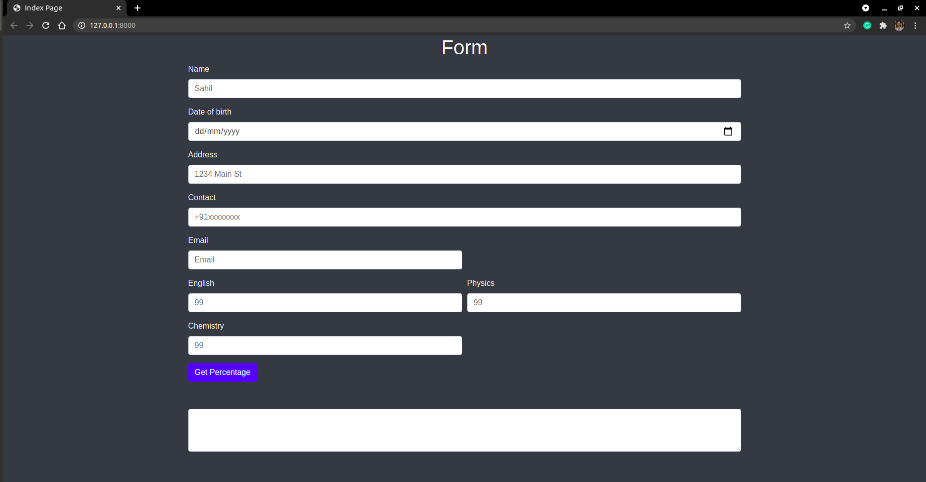

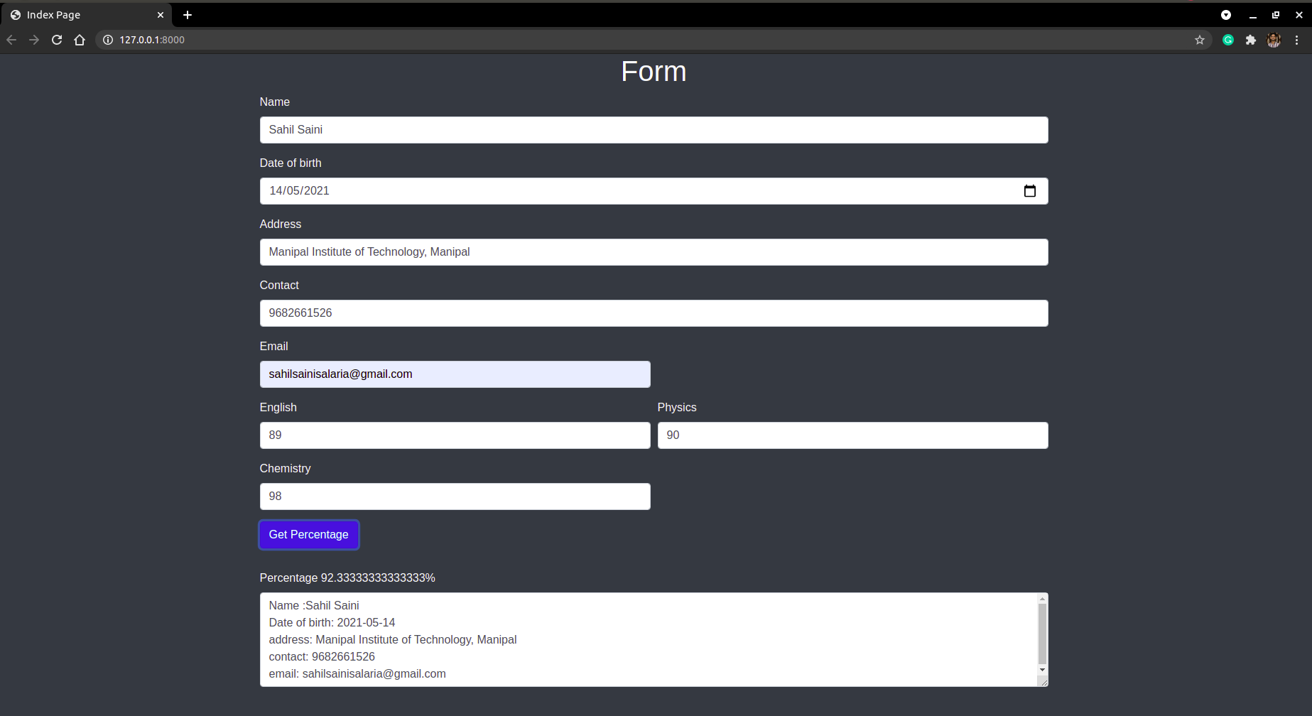

Question2

Create a web form with employee ids in dropdown list. Use a textbox for accepting
date of joining. Add a button named “Am I Eligible for Promotion”. On clicking
the button, if he has more than 5 years of experience, then display “YES” else
“NO” in the label control.

Project App Files

same as of above question files

User App Files

app.py

from django.apps import AppConfig

class QuestionConfig(AppConfig):
default_auto_field = 'django.db.models.BigAutoField'
name = 'Question'

urls.py

from django.contrib import admin
from django.urls import path

from Question import views

urlpatterns = [
path('admin/', admin.site.urls),
path('', views.index),
]

views.py

from django.shortcuts import render

# Create your views here.

from django.http import HttpResponse

def index(request):

array = [ "emp" + str(i) for i in range(15)]
context={'mylist': array}
return render(request,'index.html',context=context)

Templates

index.html

<!DOCTYPE html>
<html lang="en">

<head>
<meta charset="UTF-8">
<meta http-equiv="X-UA-Compatible" content="IE=edge">
<script src="https://ajax.googleapis.com/ajax/libs/jquery/3.5.1/jquery.min.js"></script>
<meta name="viewport" content="width=device-width, initial-scale=1.0">
<link rel="stylesheet" href="https://stackpath.bootstrapcdn.com/bootstrap/4.4.1/css/bootstrap.min.css"
integrity="sha384-Vkoo8x4CGsO3+Hhxv8T/Q5PaXtkKtu6ug5TOeNV6gBiFeWPGFN9MuhOf23Q9Ifjh" crossorigin="anonymous">
<title>Index Page</title>
<script>

function calculate_yr(dob) {
var diff_ms = Date.now() - dob.getTime();
var age_dt = new Date(diff_ms);

// alert(Math.abs(age_dt.getUTCFullYear() - 1970))
return Math.abs(age_dt.getUTCFullYear() - 1970);
}

$(document).ready(function () {
$("button").click(function () {
var dateOfJoin = $("#dateOfJoin").val();
var d = new Date(dateOfJoin);

if (calculate_yr(d) > 5) {
$("#cont").val("Yes!");
}
else{
$("#cont").val("No!");

}

return false; // prevents submission
// $("textarea#ExampleMessage").html(result.exampleMessage)

});
});
</script>

</head>

<body class="bg-dark">
<div class="container" style="text-align: center;">
<h1 class="text-light">Form</h1>
</div>
<div class="container text-light ">
<label for="Employee Ids">Choose your Id:</label>
<select id="cars" name="cars">
{% for i in mylist %}
<option style="background-color: wheat;">{{i}}</option>
{% endfor %}
</select>

</div>

<div style="height:30px"></div>
<div class="container text-light ">
<label for="Date of joining">Date of joining</label>
<input type="text" name="gender" id="dateOfJoin" placeholder="2015-03-25"><br>

</div>

<div style="height:30px"></div>

<div class="container text-light ">
<button type="submit" class="btn btn-primary">Am I Eligible for Promotion</button>

</div>
<div style="height:30px"></div>

<div class="container text-light ">
<label for="exampleInputEmail1" class='control-label' id="cont_label"></label>
<input type="text" name="cont_name" id="cont">
</div>

</body>

</html>

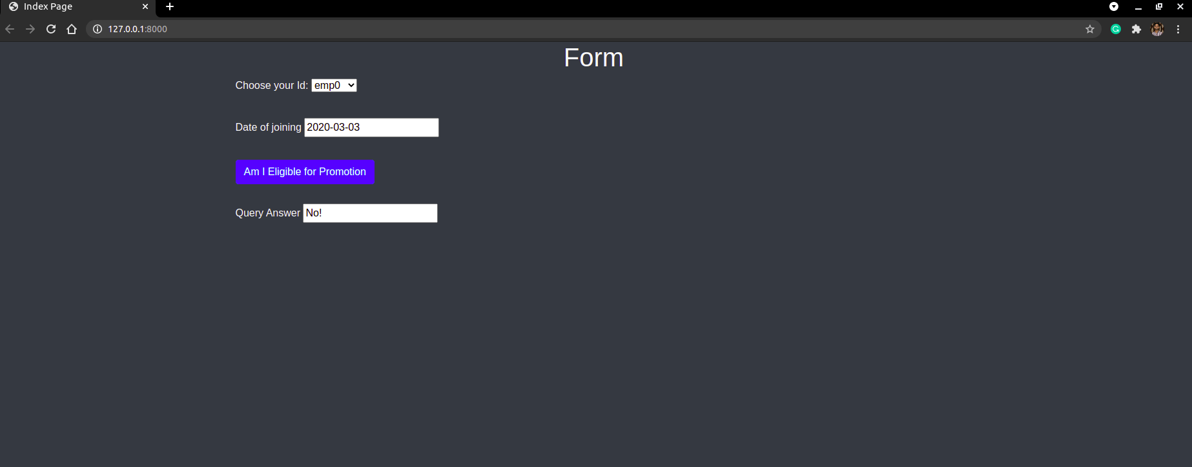

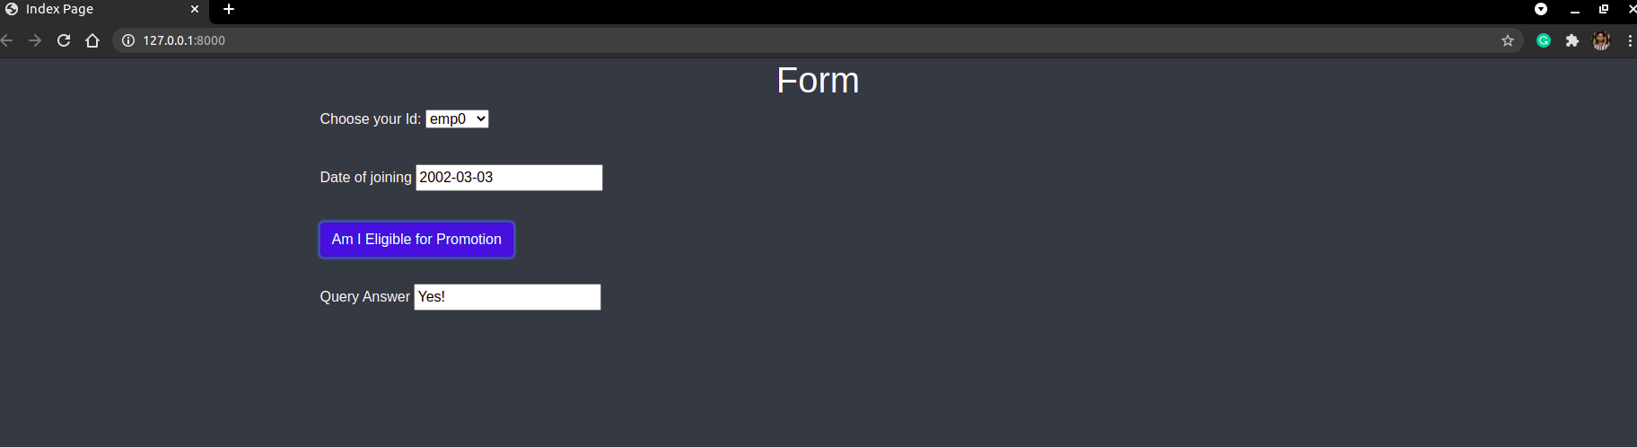

Question3

Develop a simple web page to perform basic arithmetic operations. Take two
integer inputs from the user, select the operation to be performed using a
dropdown. Include a button “Calculate” to perform the selected operation, and
then display the result in the same web page.

Project App Files

same as of above question files

apps.py
from django.apps import AppConfig

class QuestionConfig(AppConfig):
default_auto_field = 'django.db.models.BigAutoField'
name = 'Question'

urls.py

from django.contrib import admin
from django.urls import path

from Question import views

urlpatterns = [
path('admin/', admin.site.urls),
path('', views.index),
]

views.py

from django.shortcuts import render

# Create your views here.

from django.http import HttpResponse

def index(request):

arithmetic_operators = ["+", "-", "*", "/", "**"]
context = {'mylist': arithmetic_operators}
return render(request, 'index.html', context=context)

Templates

index.html

<!DOCTYPE html>
<html lang="en">

<head>
<meta charset="UTF-8">
<meta http-equiv="X-UA-Compatible" content="IE=edge">
<script src="https://ajax.googleapis.com/ajax/libs/jquery/3.5.1/jquery.min.js"></script>
<meta name="viewport" content="width=device-width, initial-scale=1.0">
<link rel="stylesheet" href="https://stackpath.bootstrapcdn.com/bootstrap/4.4.1/css/bootstrap.min.css"
integrity="sha384-Vkoo8x4CGsO3+Hhxv8T/Q5PaXtkKtu6ug5TOeNV6gBiFeWPGFN9MuhOf23Q9Ifjh" crossorigin="anonymous">
<title>Index Page</title>
<script>

$(document).ready(function () {
$("button").click(function () {

var num1 = $("#num1").val()
var num2 = $("#num2").val()

var Operator = $("#op").val()
var res = eval(num1 + Operator + num2)

// alert(Operator)
// alert(res)

$("#cont").val(res)

return false; // prevents submission
// $("textarea#ExampleMessage").html(result.exampleMessage)

});
});
</script>

</head>

<body class="bg-dark">
<div class="container" style="text-align: center;">
<h1 class="text-light">Form</h1>
</div>

<div class="container text-light ">
<label class='control-label'>Enter First Number </label>
<input type="text" name="cont_name" id="num1">
</div>
<div style="height:30px"></div>

<div class="container text-light ">
<label class='control-label'>Enter Second Number</label>
<input type="text" name="cont_name" id="num2">
</div>

<div style="height:30px"></div>

<div class="container text-light ">
<label for="Employee Ids">Operator:</label>
<select id="op" name="cars">
{% for i in mylist %}
<option style="background-color: wheat;">{{i}}</option>
{% endfor %}
</select>

</div>

<div style="height:30px"></div>

<div class="container text-light ">
<button type="submit" class="btn btn-primary">Calculate</button>
</div>
<div style="height:30px"></div>

<div class="container text-light ">
<label for="exampleInputEmail1" class='control-label' id="cont_label">Result</label>
<input type="text" name="cont_name" id="cont">
</div>

</body>

</html>

Output
